TEXT-BASED EMOTION DETECTION USING MACHINE LEARNING

Group Members Name Student ID
Member 01: Sourav Saha 0112330638
Member 02: Saptarshi Biswas Supty 0112330221
Member 03: Tridib Karmokar 0112230787

Course Information:
Course Title : Artificial Intelligence Labratory
Course Code : CSE 3812
Section : I

Project Information
Project Name : Text-Based Emotion Detection Using Machine Learning

Submitted To:
Md. Tanvir Raihan
Lecturer, Department of CSE
United International University

Submission Date:
19 / 06 / 2026

1. Introduction
Emotion detection is an important application of Artificial Intelligence and Natural Language Processing (NLP). It helps computers understand human emotions from written text.
This project develops an emotion prediction system that receives user text and automatically predicts emotional categories using machine learning algorithms.
Several classification algorithms were tested and compared to identify the best performing model.
The final system also includes a Gradio interface for real-time emotion prediction.

2. Dataset Description
Dataset Collection
The dataset used in this project was collected from publicly available text-based emotion datasets and processed for multi-class emotion classification.
Dataset Source
Kaggle Dataset Repository
Dataset Link:
https://www.kaggle.com/code/shivamburnwal/speech-emotion-recognition
Search keywords: "Emotion Detection Dataset" or, "Text Emotion Classification Dataset"
Number of Samples
Approximately 100,000+ text samples.
Data Type
Structured CSV Dataset
Columns:
• Text
• Emotion Label
Emotion Classes
- Fun
- Surprise
- Neutral
- Enthusiasm
- Happiness
- Hate
- Sadness
- Empty
- Love
- Relief
- Anger

3. Data Preprocessing
The following preprocessing techniques were applied:
• Converted all text to lowercase
• Removed URLs
• Removed special characters
• Removed unnecessary spaces
TF-IDF Vectorization was used to convert text into numeric vectors.

4. Model Selection
The following machine learning models were trained and evaluated:
Logistic Regression
Linear classification model.
AdaBoost
Boosting-based classifier.
XGBoost
Advanced gradient boosting classifier.
Naive Bayes
Probability-based classifier.

5. Experiments and Results
Accuracy Comparison
Model | Accuracy
XGBoost | 80.86%
Logistic Regression | 80.61%
Naive Bayes | 70.02%
AdaBoost | 57.84%
Best Model: XGBoost

Figure 1: Bar Graph
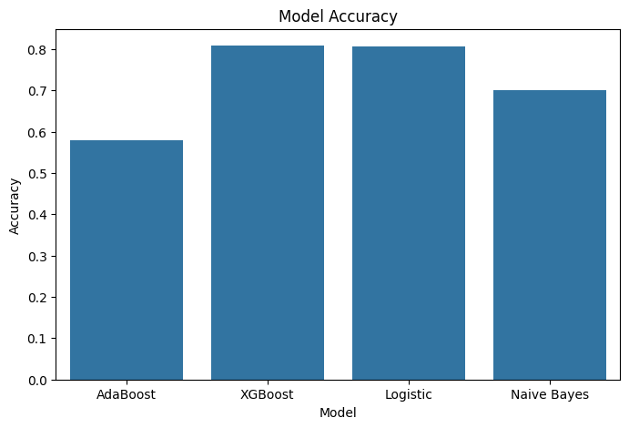
Observation: XGBoost achieved the highest accuracy.

Figure 2: Pie Chart

Observation:
The pie chart visually shows that:
- XGBoost and Logistic Regression contributed the highest performance.
- AdaBoost occupied the smallest accuracy portion.
- Naive Bayes achieved moderate performance.

Figure 3: Confusion Matrix

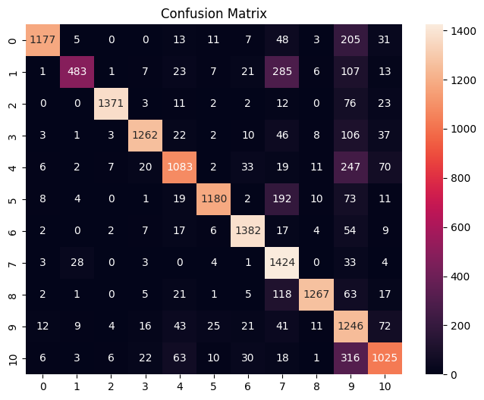

Observation:
- Strong diagonal values indicate correct predictions.
- Some emotions overlap due to semantic similarity.

Figure 4: Dataset Distribution

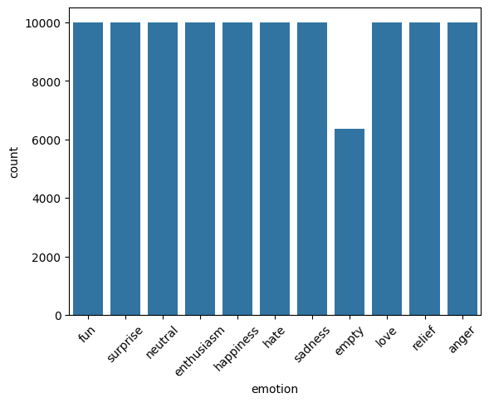
Observation:
The dataset is mostly balanced across emotion classes.

6. Result Analysis
Experimental analysis shows that XGBoost achieved the best performance with 80.86% accuracy.
Logistic Regression also produced highly competitive results.
Naive Bayes achieved acceptable performance but was lower than XGBoost.
AdaBoost produced the weakest result among all models.
Confusion matrix analysis indicates that classes with similar emotional meaning sometimes generated classification overlap.
Balanced class distribution helped reduce model bias.

7. Conclusion
This project successfully developed a machine learning-based emotion detection system capable of identifying user emotions from text.
Among all evaluated algorithms, XGBoost produced the best classification performance.
Future improvements may include:
• Deep Learning
• BERT Models
• Real-time deployment
• Multilingual support
Application Interface:
Gradio-based prediction interface.

8. Deployment
After successful model training and evaluation, the emotion detection system was deployed as a simple interactive web application using Gradio.
The deployment allows users to enter text directly into the interface and instantly receive the predicted emotion.
The application loads the trained machine learning model together with the TF-IDF vectorizer and label encoder to process user input and generate predictions in real time.
Technologies Used for Deployment
- Python
- Gradio
- Pickle
- Machine Learning Model
- TF-IDF Vectorizer
Deployment Workflow
User Input → Text Cleaning → TF-IDF Transformation → Model Prediction → Emotion Output

Deployment Screenshots
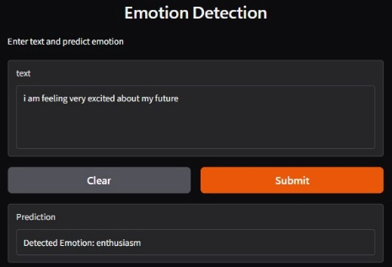 | 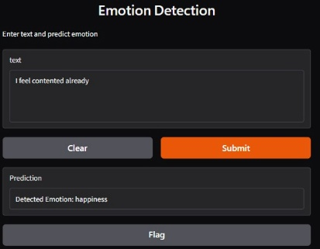 | 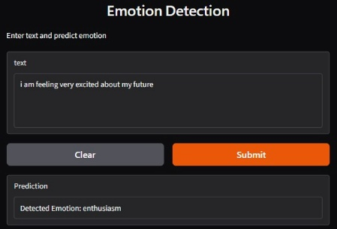

Deployment Outcome
The deployed system successfully performs real-time emotion classification and provides an easy-to-use interface for end users.
This deployment demonstrates how machine learning models can be integrated into practical applications and used outside the development environment.

